To create Internal ALB, We need to define annotation of scheme from internet to ‘internal’.
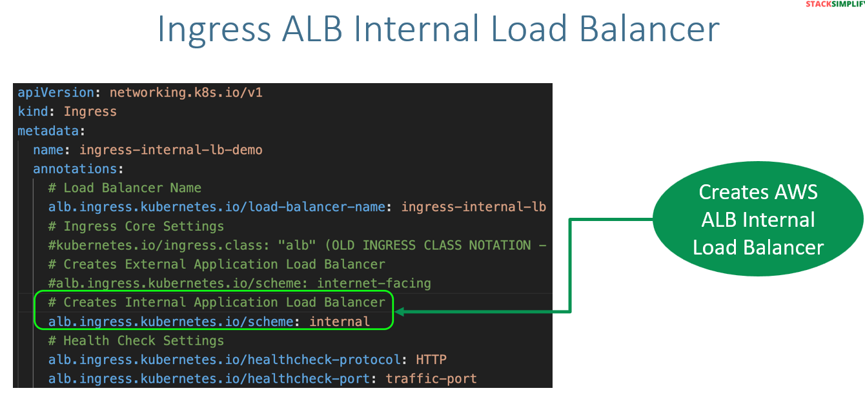
We cannot test the ALB via internet for that we will use curl POD to test this.
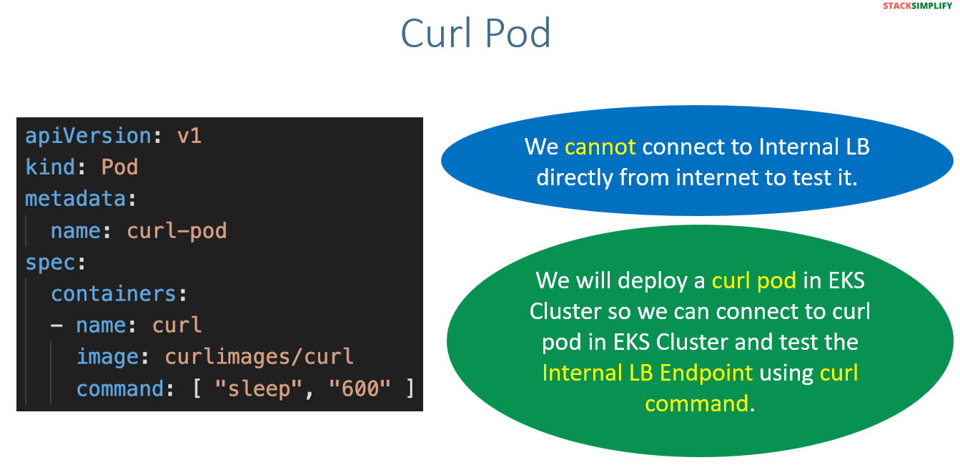
Below list of commands we are going to use to test the Ingress Internal ALB.
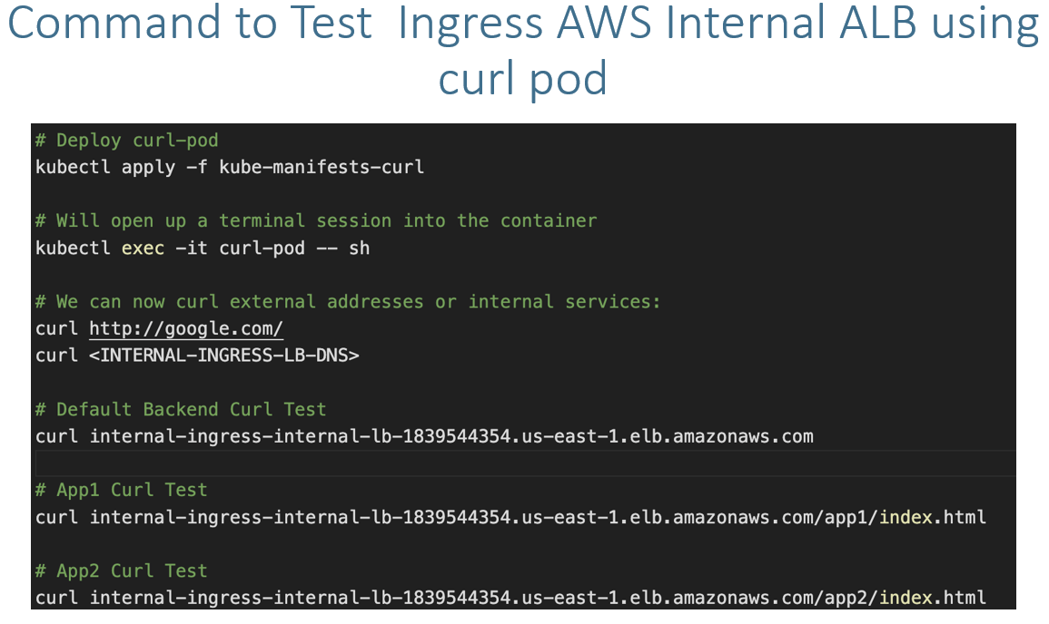
Hands on:
We will copy the scripts from ip mode we will remove the ip mode annotation. We will modify the scheme from internet to internal.
We will use the curl pod to access the internal ALB.
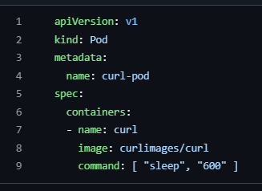
Once the curl pod is up run get ingress command
If you see the name of ALB at starting ‘internal’ is there the name will come default while you creating the internal ALB.
You can see the ALB got assigned to the ingress.
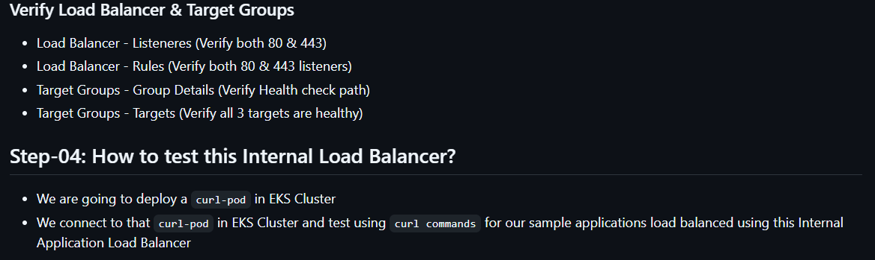
Note:- The curl-pod will communicate to internal ALB due to they are in the same network. Meantime it will get the internet access via NAT gateway.
Now login to the curl-pod and curl the ALB DNS for all 3 paths like below. 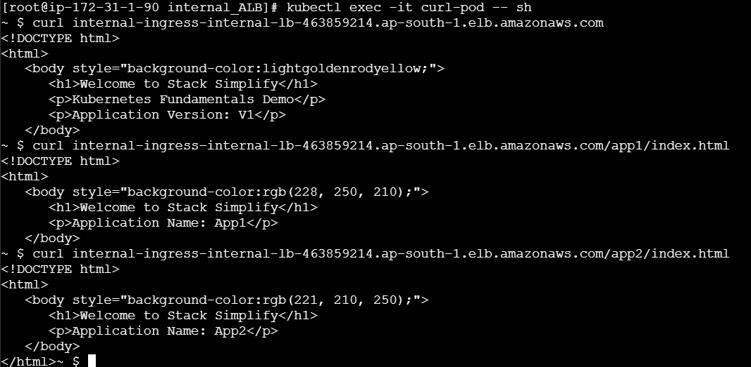
Note:- We don’t need external-DNS POD should be running while dealing with internal ALB.

